MIMOSA EAI CRIS
Version 3.2

LOGSA Implementation Guide

Prepared by
Eugene Belford
Anthony M. Orme

March 2008

Purpose

This documentation serves as a guide to the MIMOSA EAI CRIS implementation at LOGSA for the purpose of determining the feasibility of MIMOSA EAI to fulfill the requirements for storing Department of the Army CBM data.

The following topics are cover in this guide

- Installation of MIMOSA EAI CRIS.
- LOGSA Implementation
- Overview of major topic areas covered in this implementation.
- General description of design decisions.
  - Rational for decisions

Installation of MIMOSA EAI CRIS Version 3.2

To install MIMOSA EAI CRIS Version 3.2

- Login into SQLPLUS
Execute the following four MIMOSA sql scripts.

  - Step1_ORACLE_Create_Tables_and_PKs.sql
  - Step2_ORACLE_Create_Ref_Data
  - Step3_ORACLE_Create_FKs
  - Step4_Optional_Drop_Deprecated_V3-0_and_V3-1_Tables

These SQL scripts can be found on

K:\PROJECTS\ANALYSIS_Branch\CBM\CommonCBMDWdev\MIMOSA CRIS\LOGSA MIMOSA SCRIPTS\Newest Mimosa 32 and Logsa Combined

These scripts provide a standard install of MIMOSA EAI CRIS Version 3.2

Installing LOGSA MIMOSA IMPLEMENTATION

Currently the LOGSA MIMOSA CRIS implementation installs the following platforms:

- Chinook CH-47D
- Apache AH-64A/D
- Blackhawk UH60

To install the LOGSA MIMOSA implementation you will need to run the following SQL scripts:

- logsa.sql
  - Assettypes.sql
  - segmenttypes.sql
  - Network.sql
  - ChinookSegments.sql
  - ApacheSegments.sql
  - BlackhawkSegments.sql
  - Model.sql
  - measurementlocations.sql
  - ModelConfigNetworkHistory.sql
  - Ch47D.sql
  - uh60.sql
  - Ah64.sql

MIMOSA Entities Used For LOGSA Implementation

Enterprise – The corporate level of an organization; associated with one enterprise type. Registers and births sites. Mimosa assigns a Unique Integration Code (UIC).

The LOGSA implementation currently contains the following four Enterprises birth by MIMOSA

ENTERPRISE | UIC
USAMC Logistics Support Activity | 1072
AMCOM | 1053
CECOM | 1054
TACOM | 1062

Site - An Enterprise defined object. Registers and births Segments, Assets, Agents, databases, and Measurement Locations.

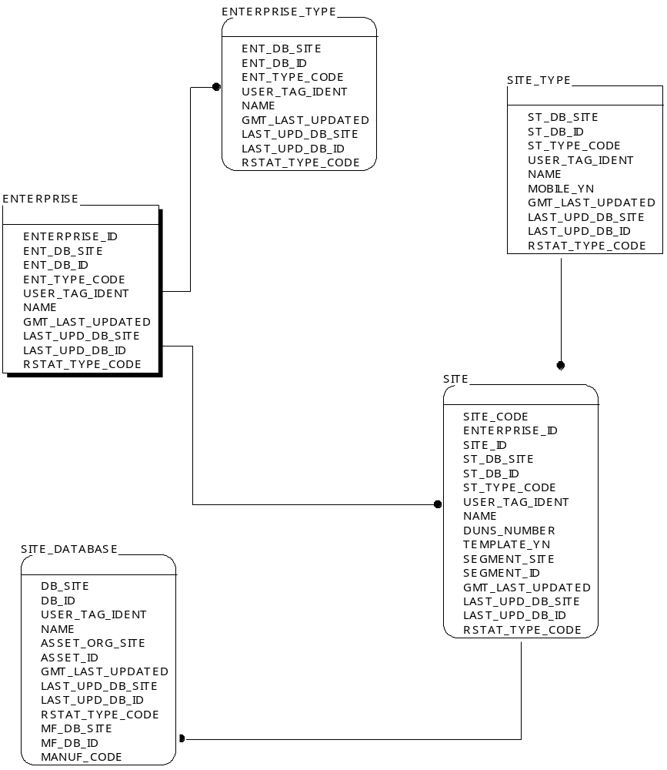
MIMOSA Terminology

Enterprise – The corporate level of an organization; associated with one enterprise type. Registers and births sites. Mimosa assigns a Unique Integration Code (UIC).

Enterprise Type – A kind of Enterprise

Enterprise UIC – A globally unique, non-repeating integer assigned to an Enterprise. 4 byte non-negative integer.

Site - An Enterprise defined object. Registers and births Segments, Assets, Agents, databases, and Measurement Locations.

Site Type - A kind of Site

Site/Site Type Child Structures – A taxonomy of Site Type classifications which have a super-class which may be divided into subclasses

Site Template – a logical site which can be used as a prototype for physical Site Instances

Site UIC – The Enterprise assigned UIC. Comprised of (Enterprise UIC+site id)

Model – Identifies a class or subclass of a Manufacturer’s products as defined by Manufacturer. Only 1 instance can be associated with only one instance a specific asset and is associated with exactly 1 asset type.

Model Child Structure – A taxonomy of manufacturer’s product which has revision “releases” and/or may be divided into lots.

Manufacturer/Maker – The organization which designs Models of assets and makes Assets

Segment - Associated with a Model.

An as designed functional area or breakdown structure for a Model. Each Model associated Segment is associated with exactly one Segment Type. Normally appear on the Engineering drawings. Segments may be decomposed into one or more Segment Child Structures. A Model associated Segment can have as-designed Measurement Locations.

Associated with an Asset.

An As-Built/As-Maintained functional area or breakdown structure for a serialized asset. Each Asset associated Segment is associated with exactly one Segment Type. Segments may be decomposed into one or more Segment Child Structures. An Asset associated Segment can have as-built/as-monitored Measurement Locations.

Segment Child Structure – A default decomposition of Segments into multiple sub-segments to form a breakdown structures.

Segment Type – a kind of Segment and has a unique Segment Type UIC.

Segment Type Child Structure – A taxonomy of Segment Type classifications.

Segment UIC – A site assigned unique identifier of a Segment. Segment UIC is composed of (Site UIC + Segment Id)

